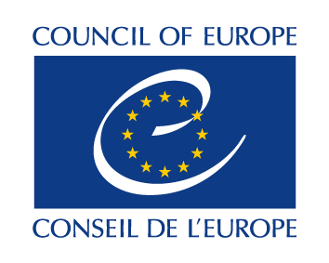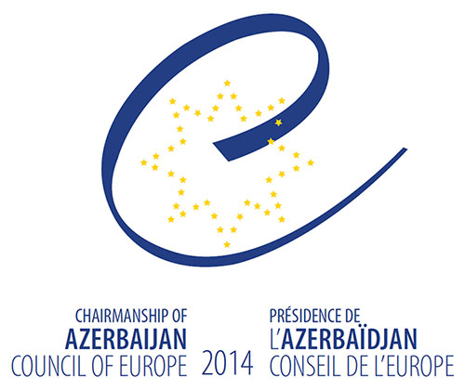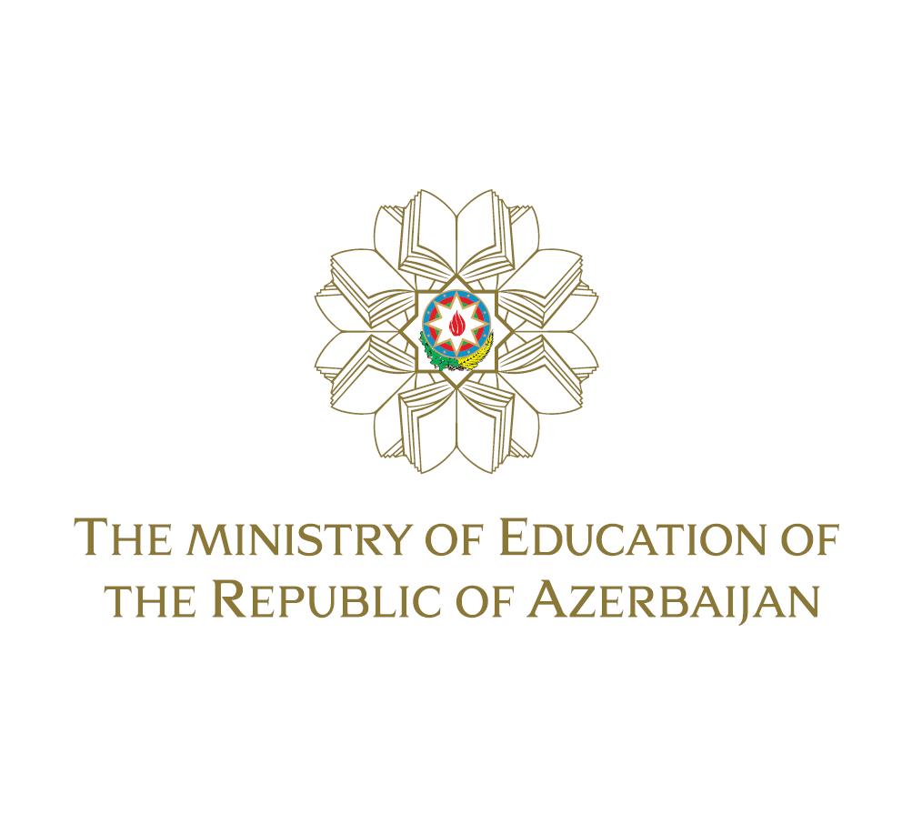

Regional Meeting of Ministers of Education on the Implementation of the European Higher Education Area

DECLARATION

22 - 23 October, 2014
Baku, Azerbaijan

We, the Heads of Delegations participating in the Regional Meeting of Ministers of Education on the implementation of the European Higher Education Area held in Baku on 22-23 October 2014, organised in the framework of the Chairmanship of the Republic of Azerbaijan of the Committee of Ministers of the Council of Europe,
- recalling that our countries are focused on implementing structural higher education reforms in line with the goals and principles of the European Higher Education Area (EHEA);
- conscious that structural reforms - qualifications frameworks, quality assurance, the recognition of qualifications and transparency instruments - are important elements of the EHEA reform process, leading to more comparable and compatible higher education systems;
- acknowledging that structural reforms in the higher education systems are impossible to implement without working towards full institutional autonomy and academic freedom;

- acknowledging that ethics and integrity represent core principles of quality education;

- acknowledging that the development, self-certification and implementation of national qualifications frameworks is an important and challenging task in which the sharing of experience among countries is of vital importance;

- expressing our appreciation of the support of the Council of Europe in exchanging experiences in the development of the national qualifications frameworks and through Co-Chairing the Structural Reforms Working Group of the Bologna Process,

Adopt the following Declaration:
- We confirm that the implementation of the European Higher Education Area remains a high priority for education policy and practice in our countries in the coming years;

- We welcome the results of the 2nd meeting of the regional network of correspondents for national qualifications frameworks, established by the 2nd Informal Regional Ministerial meeting (November 2012, Strasbourg), which enabled them to extend the sharing of experience and good practice in the implementation of their national qualifications frameworks, linking it to quality assurance issues;

- We underline the importance of internal and external quality assurance in higher education and are willing to establish closer co-operation with existing networks of professionals in the field (for example ENQA, CEENQA) and among our countries on regional and bilateral basis, also by including a quality assurance perspective in the work of the regional network of correspondents for national qualifications frameworks;

- We are committed to promoting ethics and integrity in our education systems in order to ensure quality education;

- We will continue regular exchanges of information and good practice at Ministerial level on the progress of higher education structural reforms in our region and will work to strengthen transparency by providing information on our higher education systems, qualifications and policies among ourselves and to other countries of the EHEA;

- We encourage the dissemination of the goals and principles of the Bologna Process to countries that are not members of the European Higher Education Area;

- We call upon the Council of Europe as well as the European Union and other international institutions to support and contribute to the promotion and implementation of bilateral and regional co-operation in the field of the higher education structural reform process.

Azerbaijan, Georgia, Kazakhstan, Moldova, Russian Federation, Ukraine and Belarus as observer

