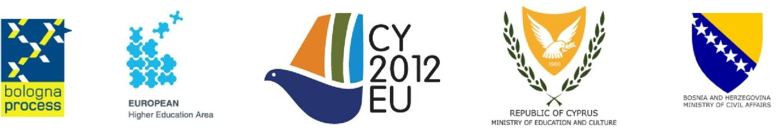

Doc. Code: BGUG_CY_BA_33_7b

Countries for the Nomination of
EQAR Register Committee Observers
The following five countries responded to the call for observers to the EQAR Register Committee:

- Austria
- Belgium/Flemish Community
- France
- Germany
- Turkey

