Doc. Code: BFUG_DK_AZ_30_9c
Bologna Process – European Higher Education Area
Manual of the Bucharest Ministerial Conference and of the Third Bologna Policy Forum
26-27 April 2012, Palace of the Parliament, Bucharest

Contents
A. Conference overview 3
i) About the Bologna Process/ the European Higher Education Area 3
ii) Programme of the Bucharest Ministerial Conference and of the Bologna Policy Forum, April, 26-27th, 2012 4
iii) Conference documents 7
iv) Chairing procedure 8
v) Conference website 9
B. Traveling to Romania, Bucharest 10
i) Visa Information 10
ii) Currency 10
iii) Exchange rate 10
iv) ATMs (Cash Machines) 10
v) Language 10
vi) Local travel 11
vii) General information 14
viii) About Bucharest 14
C. Conference logistics 15
i) Online registration for the Bucharest Ministerial Conference 15
ii) Airport arrival and transfers to Bucharest 15
iii) Accommodation 16
iv) Venues 18
1. Palace of the Parliament 18
v) Transfers to / between conference locations 19
vi) Conference packages 19
D. Conference facilities 20
i) Plenary rooms 20
ii) Parallel session rooms: 20
iii) Bilateral meetings 20
iv) BFUG meeting 20
v) Conference languages 21
vi) Wi-Fi Internet 21
vii) Live web-streaming 21
viii) Access to computers and copy machine 21
ix) Medical services 21
E. Security 21
F. Media 22
i) Media accreditation 22
ii) Access to the Palace of the Parliament and to the works of the conferences 22
iii) Press releases and press conference 22
iv) Media facilities 22
G. Associated events, exhibitions and conference stands 22
H. Emergency numbers and contact persons 22
I. About Romania. Remarkable personalities 23

Conference overview

About the Bologna Process/ the European Higher Education Area
The Bologna Process has reformed the structures of European higher education systems over the past ten years and has played a remarkable role in strengthening the competitiveness and attractiveness of European higher education. It is a widely known hallmark of higher education in Europe.

The European Higher Education Area (EHEA) is an intergovernmental cooperation arrangement formally established at the ministerial conference held in Budapest and Wien in March 2010. It was launched as the Bologna Process at a ministerial conference in Bologna in June 1999 and was inspired by the meeting of the ministers responsible for higher education of France, Germany, Italy and the United Kingdom held in 1998.

Purposes
The EHEA aims at developing a higher education area which:
- builds on academic freedom, institutional autonomy and student and staff participation in higher education governance;
- fosters quality, economic attractiveness and social cohesion;
- encourages students and staff to move freely;
- develops the social dimension of higher education;
- fosters employability and lifelong learning of graduates;
- sees students and staff as members of the academic community;
- is open to and cooperates with higher education in other parts of the world.

The EHEA coordinates structural reforms between governments such as:
- Introduction of a system of comprehensible and comparable degrees (the three-cycle system of Bachelor, Master and Doctorate);
- Providing transparency regarding contents of study by means of credit points (ECTS) and the Diploma Supplement;
- Recognizing qualifications (degrees and periods of study);
- Establishing a shared European understanding of quality assurance;
- Implementing a Qualifications Framework for the European Higher Education Area.

The Bucharest Ministerial Conference gives the signal the Bologna Process needs to unfold its action on three directions, all of them completing the structural reforms. In depth implementation is needed in order to consolidate the impact of the structures. The Bologna reforms rely substantially on each other, so their impact needs to be enhanced by their interplay. In the same time, structural reforms need to continue in various parts of the European Higher Education Area, until all countries are high achievers under all action lines.

The scope of the transformations generated and associated with the Bologna Process goes far beyond structures. The European Higher Education Area is built on members’ commitment to upholding values that can be considered the European normative perspective of the University of the 21st century. Amongst these, one can list academic freedom, university autonomy, stakeholders’ involvement, but also public responsibility, accountability and service to the society.

The main political goals set by the Bucharest Communiqué are: to enhance graduates’ employability, to provide quality higher education for all, and to strengthen mobility as a means for better learning within the EHEA.

Under organizational aspects, the Bologna Process is a voluntary cooperation between governments, the Council of Europe, the European Commission, UNESCO, European data collectors and stakeholder organizations. The political directions are set by the ministerial conferences, while implementation is coordinated by appointees of the members, which meet in the Bologna Follow-Up Group. The Bologna Follow-Up Group Secretariat offers support and assistance in the execution of the work plan. The memory of the process is organized in the permanent website and the archive, both of them developed by the Romanian Secretariat.

In order to bring the researchers voice into the Process, the Romanian authorities have organized the “Future of Higher Education – Bologna Process Researchers Conference” in 2011, as an associated event, previewing the ministerial conference.

Programme of the Bucharest Ministerial Conference and of the Bologna Policy Forum, April, 26-27th, 2012

25 April 2012
Cocktail and Welcome Buffet Dinner
26 April 2012, Palace of the Parliament
09:00 – 12:00 Bilateral meetings (optional)
11:00 – 12:00 Arrival and registration
12:00 – 13:30 EHEA Ministerial Conference official Opening – Plenary Session
Chair: Cătălin Ovidiu Baba – Minister for Education, Research, Youth and Sports in Romania
Speakers:
- Cătălin Ovidiu Baba, Romanian Minister for Education, Research, Youth and Sport in Romania (10 min)
- Morten Østergaard, Danish Minister for Science, Innovation and Higher Education (5 min)
- Gulu Novruzov, Azeri Vice-Minister of Education (5 min)
- Androulla Vassiliou, European Union, Commissioner for Education, Culture, Multilingualism and Youth (5 min)

Bologna Process implementation and challenges ahead – Interactive panel
Chair: Germain Dondelinger (Co-Chair of the Working Group on The Bologna Process Implementation)
Eurydice speaker and Andrejs Rauhvargers, Co-Chair of the Working Group on The Bologna Process Implementation (tbc) - Bologna Process implementation report – main conclusions and way forward (15 min)
Reactions and discussion with the heads of delegation of the BFUG Consultative members (roundtable – 8 consultative members: Council of Europe, UNESCO, EUA, EURASHE, ESU, ENQA, EI and Business Europe) (50 min)
15:00 – 16:30 EHEA Ministerial Conference - Parallel sessions  Moderated by the Ministers from Romania, Denmark, Azerbaijan and Armenia  Aim: Discussing the Bucharest Communiqué | 15:00 – 16:30 BPF Information and mutual exchange session 1 - Plenary session  Title: The Bologna Process – A Catalyst for Reform in other regions?  Moderator: Hilligje van’t Land, Director Membership and Programme Development, International Association of Universities (IAU) – (10 min introduction)  Format: Interactive panel– 45 min  Panelists:  - Government delegate (Head of the Senegal delegation) (tbc)  - Mongkhonvanit Pornchai, IAU Board Member / President Siam University (Thailand)  - Carlos De Feo, Secretary General, Federacion Nacional de Docentes Universitarios, CONADU (Argentina)  - Victor Sanchez, President, United States Students Association (USA)  Main questions for the panelists:  - How did the BP impact your national/ regional context?  - What are the opportunities and obstacles for inter-governmental cooperation, similar to the Bologna Process, in your region?  Moderated discussion with questions from the audience – 35 min
16:30 – 17:00 Coffee Break
16:45 – 17:00 Family photo EHEA heads of delegation
Family photo EHEA and non-EHEA heads of delegation
17:00 – 18:30 EHEA Ministerial Conference - Plenary Session  Chair: Morten Østergaard, Danish Minister for Science, Innovation and Higher Education  Aim: Finalising the discussions on the Bucharest Communiqué  Keynote speaker:  Sir Peter Scott (IOE) – General Rapporteur of the Future of Higher Education – Bologna Process Researchers’ Conference (FOHE-BPRC) | 17:00 – 18:30 BPF Information and mutual exchange session 2 - Plenary session  Theme - Qualifications Frameworks and their role in academic and professional recognition  Chair: Jean-Philippe Restoueix, Council of Europe  Interactive panel discussion with participants from the Malaysia, Morocco, the US (Lumina Foundation) Australia, South Africa, Chile and Ireland (panelists tbc) – 60 min  Main questions to be addressed by speakers:  - Why has a QF been developed for higher education in your country/ region?  - What was the process for developing it?  - What were the challenges in developing it?  - Do you believe it is accomplishing its intended goal? How do you know this is the case?  Question and answers with the public: 30 min
18:30 – 19:00 Transfer to the hotels from the Palace of Parliament
20:00 – 20:30 Transfer to the Festive Evening Event from the hotels
20.30 Festive Evening Event / Official dinner
27 April 2012, Palace of the Parliament
08:00 - 09:00 Transfer from the hotels to the Palace of Parliament
Bilateral meetings (optional)
09:00 – 10.30 Bologna Policy Forum Official Opening - Plenary session
Chair: Gulu Novruzov, Azeri Vice-Minister of Education
Welcome words:
- Cătălin Ovidiu Baba, Romanian Minister for Education, Youth and Sports (5 min)
- Androulla Vassiliou, European Union, Commissioner for Education, Culture, Multilingualism and Youth (5 min)
Keynote speech (Shri Kapil Sibal, Indian Minister of Human Resources Development, tbc) – 15 min
Keynote speech (Hao Ping, Chinese Vice-Minister of Education, tbc) – 15 min
Discussion – 50 min
10:30 – 11:00 Coffee Break
11.00 – 12.30 Bologna Policy Forum thematic parallel sessions
Chaired by the ministers responsible for higher education in Armenia, Azerbaijan, Denmark and Romania and co-Chaired by 4 non-EHEA ministers

Parallel session 1: Global academic mobility: Incentives and barriers, balances and imbalances
Co-Chairs (tbc): Denmark and China

Parallel session 2: Global and regional approaches to quality enhancement of higher education
Co-Chairs (tbc): Romania and Brazil

Parallel session 3: Public responsibility for and of HE within national and regional context
Co-Chairs (tbc): Armenia and Canada

Parallel session 4: The contribution of HE reforms to enhancing graduate employability
Co-Chairs (tbc): Azerbaijan and Tunisia

Main questions for the debates will correspond to the questions at the end of the BPF background paper chapters.
12:30 – 12:45 Transfer from the parallel sessions rooms to the plenary hall
12:45 – 13:00 Adoption of MC Communique by the EHEA members
Chaired by Cătălin Ovidiu Baba, Romanian Minister for Education, Research, Youth and Sports
13:00 – 14:00 Discussion and adoption of the BPF Statement - Plenary session
Chaired by Cătălin Ovidiu Baba, Romanian Minister for Education, Research, Youth and Sports
14:00 – 15:00 Press conference
14:00 – 15:30 Luncheon
15:30 Departure of participants

Conference documents
The Ministerial Communiqué represents the main political document of the European Higher Education Area. It takes account of the achievements since the last ministerial conference and it sets objectives that would be operationalized in the plan of work for the upcoming sequence of the Bologna Process. It is prepared by the Bologna Follow-Up Group (BFUG).

The Report on the Implementation of the Bologna Process provides facts and analyses on the state of the art regarding the implementation of the Bologna Process at national level. It is based on questionnaires to the national authorities and on statistical evidence collected by data collectors (Eurostat, EURYDICE and Eurostudent). The report is prepared by the data collectors and the Reporting Working Group within the BFUG.

The Bologna Policy Forum Statement represents the main political outcome of the Bologna Policy Forum and sets the stage for the external dimension of the Bologna Process.
The Bologna Policy Forum thematic sessions’ background paper has the purpose to set the stage for the debates within the allocated session.

The Transparency Tools Report is a separate report on the developments in the field. Transparency is understood as provision of understandable information to the beneficiaries of higher education. The report was prepared by the Transparency Tools Working Group within the BFUG.

The ‘European Higher Education at the Crossroads: Between the Bologna Process and national reforms’ publication gathers the papers presented and discussed at the “Future of Higher Education – Bologna Process Researchers’ Conference”, held in Bucharest on 17-19 October 2011. The two volumes are meant to provide inspiration to policy makers, as they provide insights from the point of view of researchers on the Bologna Process.

Statements from EHEA consultative members and other organisations are meant to inform the ministers on the position of the issuer regarding topics that are addressed in the conference.

The Conference Manual (the current document) is a compilation of useful information put forward by the organisers for the participants of the Bucharest Ministerial Conference and the Third Bologna Policy Forum.

The Travel to Romania Guide represents an open invitation to enjoy in a more relaxed setting the beauties and the hospitality of Romania.

Chairing procedure
- Plenaries:
Participants signal their intention to intervene by raising their country’s tag during the plenary session, after the Chair has introduced the session. A speakers’ list is kept.
Maximum time for one intervention is 3 minutes.
The Chair announces that he/she will close the speakers at the end of one intervention, approximately 15 minutes before the end of the session. After this announcement, the Chair can shorten the time for interventions in order to make sure that all those on the list have time to speak, if the case.
The Chair concludes the session.

- Parallel sessions
Participants shall announce their intention to intervene by April 24th, at conference2012@ehea.info.
After the introduction of the session, the Chair presents the list of speakers that have announced beforehand their intention to address the Conference. After exhausting the initial list of speakers, the Chair invites interventions, signalled by raising the respective country’s tag.
Maximum time for one intervention is 5 minutes.
The Chair announces that he/she will close the speakers at the end of one intervention, approximately 15 minutes before the end of the session. After that announcement, the Chair can shorten the time for interventions in order to make sure that all those on the list have time to speak, if the case.
The Chair concludes the session.

- Endorsement of the Bucharest EHEA Communique and the Bologna Policy Forum Statement
Endorsement is carried through applauses.

Conference website
General information on the EHEA Ministerial Conference and Third Bologna Policy Forum are available on the official website of the event at: http://www.bologna-bucharest2012.ehea.info.
Background documents for the Bucharest Ministerial Conference will be available online at http://www.bologna-bucharest2012.ehea.info/2012-ministerial-conference.html.
Background documents for the Third Bologna Policy Forum will be available online at http://bologna-bucharest2012.ehea.info/2012-bologna-policy-forum.html.

The presentations and speeches within the Bucharest Ministerial Conference and the Third Bologna Policy Forum will be uploaded at the above specified URLs after the closing of the events.

Traveling to Romania, Bucharest

Visa Information
Please see the Romanian Ministry of Foreign Affairs website for the list of countries whose nationals must be in possession of a visa upon entry in the Romanian territory: http://www.mae.ro/en/node/2040.

If you need a visa invitation letter please write us at conference2012@ehea.info. The organisers need to be provided with the full name and passport number for each member of the delegation. A signed version of the visa invitation letter will be sent back shortly over e-mail. If an original invitation letter is required as well, please send us the postal address where it should be delivered.

Furthermore, please be advised that the organisers would only be able to provide a visa invitation letter after the registration form has been filled in and saved or submitted for each member of the delegation.

Currency
The currency of Romania is the RON = Leu (plural "Lei", pronunciation: lay). The name of the currency means "lion". It is subdivided into 100 bani (singular: ban). The leu notes in use are of equal size to euro banknotes, and are made of polymer (plastic, they don’t tear).

Exchange rate
The official exchange rate is around: 1 EUR = 4.35 LEI, 1 USD = 3.2 LEI. This rate varies slightly on a daily basis. For detailed information about the currency exchange rates, please see http://bnr.ro/Exchange-rates-1224.aspx.

ATMs (Cash Machines)
There are several ATMs in the Arrivals Terminal of the Airport, (public area) as well as near most hotels. The banks that have an ATM installed in the Arrivals terminal of the airport are: Unicredit Tiriac Bank, BRD-GSG, Credit Europe Bank, Bancpost, Alpha Bank, Piraeus Bank, BCR.

You can take out lei from almost any Credit and Debit Cards. All ATMs offer similar exchange rates and can be used with confidence. Most of the shops and restaurants accept credit cards. Travel cheques are less frequently used and can usually be exchanged only in banks. Taxis generally do not accept credit cards.

Language
The official and spoken language of Romania is Romanian (română, [roˈmɨnə]). The Romanian language descends from Latin, due to the historical circumstances. During the Middle Ages, Romanian became influenced by the Slavic languages and to some degree by Greek. During the 19th century, Romanian was influenced by French, due to cultural and academic proximity. The oldest extant document written in Romanian was dated 1521a.c.
English is widely spoken by (younger) Romanians. They also understand other Latin languages.

Local travel
Bucharest's public transportation network includes: bus (autobuz), tram (tramvai), trolleybus (troilebuz) and subway (metrou). It operates between 5:00 am and 11:00 pm.
Buses, trams, trolleybuses and express buses operate on the same kind of passes. These have to be purchased beforehand and validated upon boarding. Travelers may be asked to show the validated pass during the trip. Penalties are applied if caught without a valid ticket or pass. If you change the bus/tram/trolleybus, you need to validate again your pass. Passes can be purchased at any kiosk displaying the RATB logo.

Public transport passes (also valid for subway):
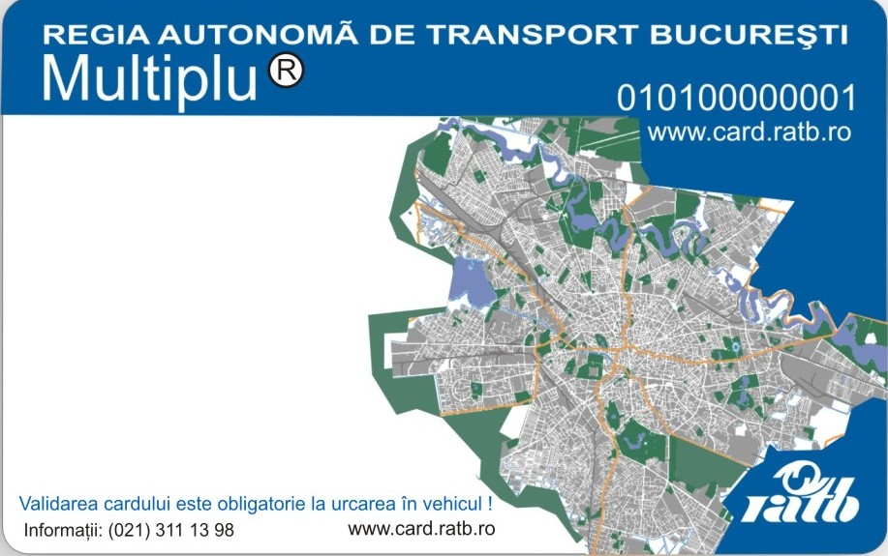 | 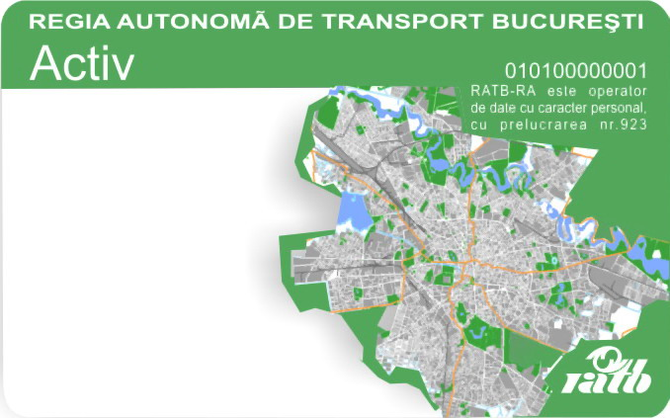
“Multiplu” pass, for multiple use.  It costs 1,6 lei (the card itself ony). Additionally, one can load on it:  - One day pass for all buses, trams and trolleybuses (8 lei);  - 2 to 8 trips with buses, trams and trolleybuses (2,6 to 10,4 lei);  - 2 express bus tickets (7 lei).  It is made of paper material. | “Active” pass, for all public transport means.  It costs 3,7 lei.  The price does not include anything else but the card. To use it, one has to load a sum of money that will be charged automatically on all transport means, including the subway.)  It is made of plastic material.

One trip with buses, trams or trolleybus costs 1,3 lei. One trip with the express bus costs 3,5 lei. There are two express lines:
- 783: Henri Coandă International Airport – “Unirii” Square (Piața Unirii), which is 10 min walking or one subway stop away from the Palace of the Parliament) and return;
- 780: : Henri Coandă International Airport – North Railway Station (Gara de Nord) and return.

To plan your trip, please visit: http://www.ratb.ro/harta.php
Subway passes can be purchased in the underground, at the entrance of the stations. Subway stations are signalled with the “M” letter. One trip costs 2 lei. The “Active” pass can be used for the subway, too.

Subway tickets and fares:
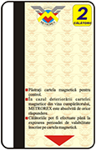 | 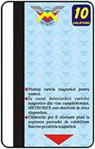 | 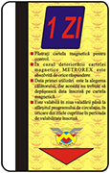 | 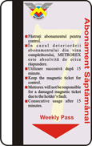
Two trip pass  4,00 Lei | Ten-trip ticket  10,00 Lei | Day Pass  6 Lei | Weekly Pass  15,00 Lei

Please find below the subway map. Please take note that the interrupted lines represent work in progress, they are not open for passengers. Generally, the subway is the fastest mean of transportation in Bucharest, especially at rush hours.

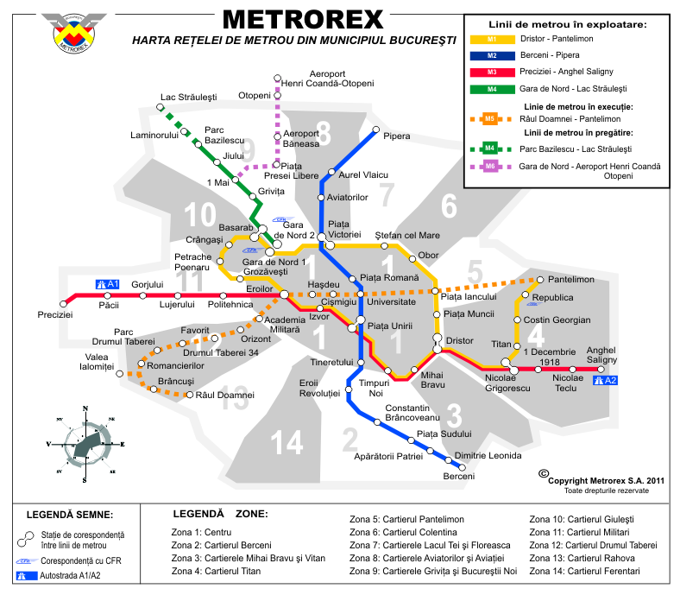
Bucharest - Hop On/ Off Sightseeing Bus Tours Hop-on, hop-off bus tours are operated daily on a fleet of new double-decker buses. Travellers can get an introduction to Bucharest's fascinating architectural mix and get familiar with the city's central neighbourhoods and places of interest in less than one hour.
Time Table: 10:00 – 22:00
Daily departures approx. every 15 minutes.
Tour duration approx 50 minutes.
Tickets: 1 day travel card.
Travel cards remain valid for 24 h after the initial validation.
Prices: 25 lei per adult.
Travel cards must be validated upon every boarding. They can be purchased on board of the buses.

More information in English can be accessed at http://bucharestcitytour.ratb.ro/index.html

General information
Temperature: 7 to 18 degrees °C during the month of April
Time zone: GMT + 2 hours
Electricity: 220V, 50Hz Standard continental European dual round-pronged plugs.
Emergency number: 112
Romania country telephone code: +40
Bucharest telephone code: 021
International calls from Romania: 00 + country code + area code + telephone number
Public telephones operate on magnetic cards. Magnetic cards are available for purchase at post offices, newspaper kiosks, and tobacco shops.

About Bucharest
Bucharest (București pronounced [bukuˈreʃtʲ]) is Romania’s capital and the biggest financial, administrative and cultural center. According to Eurostat, the Bucharest population has around 2,151,880 residents, being the 10th largest city of the European Union. Bucharest's crime rate is rather low in comparison to other European capital cities.

Bucharest hosts the biggest population of students in Romania and some of its largest universities.

Bucharest’s eclectic architecture is a mix of historical (neo-classical), interbellum (Bauhaus and Art Deco), Communist-era and modern. In the period between the two World Wars, the city's elegant architecture and the sophistication of its elite earned Bucharest the nickname of "Little Paris" (Micul Paris). Bucharest is situated on the banks of the Dâmbovița River, which flows into the Argeș River, a tributary of the Danube.

The old town Bucharest is located at the very center of the city. The area is home to many art galleries, antique shops and coffeehouses. At the centre of the historic area can be found the remains of the Old Princely Court (Curtea Veche), built in the 15th century by Vlad Țepeș [ˈvlad ˈt͡sepeʃ], also known as Vlad Dracula. The old city centre is now under partial renovation works.

Conference logistics

Online registration for the Bucharest Ministerial Conference
Participants can be registered online only following the confirmation of participation and the nomination of the contact person for the delegation. The organisers will provide over email the credentials for online registration.
To log in please access: http://www.bologna-bucharest2012.ehea.info/login.html .
Please be advised that the online registration forms must be completed and submitted for each member of the delegation by the 1st of April, the latest.

Airport arrival and transfers to Bucharest
After finalising the travel formalities, the participants will be further guided at the dedicated Information desk at the “Arrivals” terminal of the airport.

The information desk will be marked accordingly with the EHEA / Bologna Process logos. The participants will be informed about the schedules of the specific shuttles leaving for each of the official hotels and will be guided accordingly to ensure an efficient transfer towards the hotels / Conference venue.

Shuttles will be made available for transport at / from the official hotels and / or the Palace of the Parliament on 25 and 26 April 2012. The buses will be marked with the official Conference logos and the designated personnel will take the participants from the Info Desk to the shuttles.

Henri Coandă International Airport (Romanian: Aeroportul Internaţional Henri Coandă) is Romania's busiest international airport, located 16.5 km (10.3 mi) northwest of Bucharest, within the Otopeni town limits.
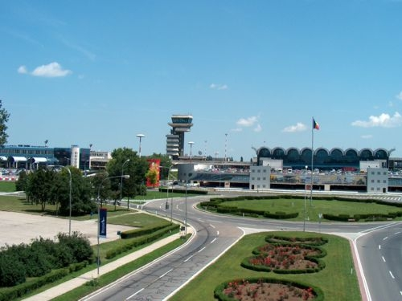

Henri Coanda Airport opened a new terminal at the end of March 2011. It has 24 boarding gates, 14 boarding bridges, 4 VIP lounges and 104 check-in desks. It is violin shaped and it is called “The Finger Terminal”.
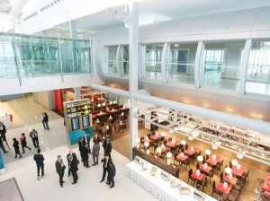

Accommodation
Participants can choose to stay in one of the official hotels reserved by the organisers for the event or they can opt for a different accommodation. The five official hotel rooms are in the vicinity of the Palace of the Parliament (2 km radius). Transfer and security will be arranged only for the official hotels.

The official hotels of the event have a limited number of rooms at a special discounted rate. In order to make the hotel reservations, participants must fill in the hotel registration form and send it via e-mail or fax as instructed before the deadline.

Please note that most hotels require a guarantee for both accommodation and extra services upon check in, either by credit card or cash. It is the responsibility of each participant to make their own hotel reservation in due time.

The five official hotels of the event are listed below:
Intercontinental Hotel - 5 stars
Rates: 100 – 140 EUR
Deadline for registration: 31 March 2012
(130 rooms available)

JW Marriott Bucharest Grand Hotel – 5 stars
Rates: 513 – 567 RON (Approx. 116 EUR – 130 EUR)
Deadline for registration: 23 March 2012
(130 rooms available)
Radisson Blu Bucharest Hotel – 5 stars
Rates: 500 – 550 RON (Approx. 114 EUR – 125 EUR)
Deadline for registration: 26 March 2012
(80 rooms available)

Novotel Hotel - 4 stars
Rates: 80 – 105 EUR
Deadline for registration: 25 March 2012
(70 rooms available)
Ibis Palace of Parliament Hotel – 3 stars
Rates: 55 – 64 EUR
Deadline for registration: 30 March 2012
(70 rooms available)

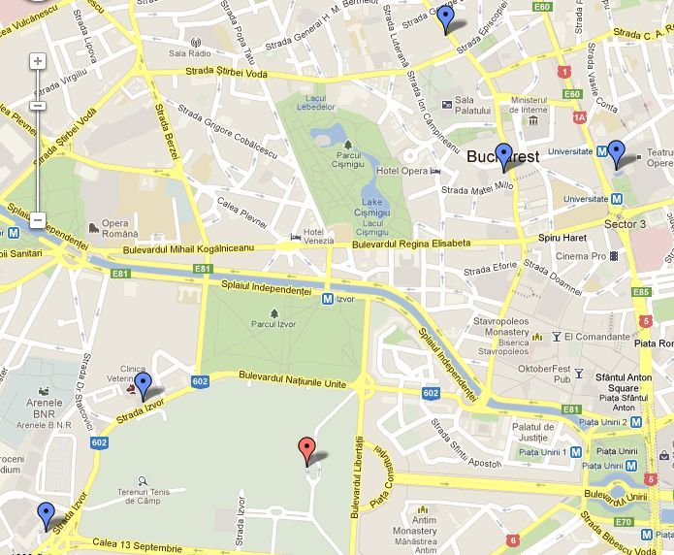
Radisson Blu Hotel
Novotel Hotel
Intercontinental
Hotel
JW Mariott Grand Hotel
Ibis Palace of
the Parliament Hotel
Palace of
the Parliament

Venues

Palace of the Parliament

All conference sessions will be hosted by the Palace Of The Parliament (2-4 Izvor str., District 5, Bucharest). Bilateral meeting facilities will be offered in the same location.

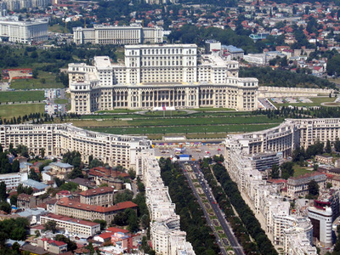

Ministerial conference participants will use the main entrance (C1). Participants should be prepared for identity and security checks at the entrance. Please note that the Palace of the Parliament forbids the access with the usual forbidden objects as in an airport security check filter, except for the restrictions on liquids. Should your delegation include any security personnel, please contact your Embassy and the organizing team in order to proceed with the necessary formalities needed according to the Romanian regulations.

The Palace of the Parliament is the largest civilian building in the world. It was built by Communist Party leader, Nicolae Ceausescu, (formerly known as the People's Palace,) and it took 20,000 workers and 700 architects to build. The palace boasts 12 stores, 1,100 rooms, a 328-ft-long lobby and four underground levels, including an enormous nuclear bunker. When construction started in 1984, the dictator intended it to be the headquarters of his government. Today, it houses Romania's Parliament and serves as an international conference centre. Built and furnished exclusively with Romanian materials, the building reflects the work of the country's best artisans. The interior is a luxurious display of crystal chandeliers, mosaics, oak panelling, marble, gold leaf, stained-glass windows and floors covered in rich carpets.

Transfers to / between conference locations
Transportation will be ensured by the Romanian organizers in shuttle system, with security arrangements, from and to all the locations of the conference. The transfers will be organized as follows:
- From the five official conference hotels to the Palace of the Parliament and return: departure and return times will be made available at the reception desk or/and displayed in the lobby of the hotel;
- From the five official conference hotels to the dinner location and return: the transfer times are specified within the latest version of the conference programme and will be reconfirmed by the organisers in due time;
- The organizers will provide a shuttle service on 27 and 28 April 2012 to the International Airport Henri Coanda (Otopeni) from the venue (The Palace of the Parliament) and from the recommended official hotels. Upon arrival, please specify to the organisers whether you will need to be picked up for the airport transfer from an official conference hotel or from the Palace of Parliament, as well as the required pick-up time.

Please note that security arrangements will be available only for the official conference shuttles. Please also note that only pre-accredited vehicles are allowed in the parking of The Palace of the Parliament.

Conference packages
The participants will receive badges and conference bags containing conference documents. For security reasons, participants are kindly requested to wear badges throughout the conference, including at social events, as well as when using transportation services offered by the organisers. Conference badges are mandatory for passing security controls at each location of the conference, and participants will be required to show a valid ID (passport or identity card) for receiving their badge either at the hotels’ information desks or at the entrance of the conference venue.

The conference packages will be distributed as follows:
- On April 25th, at the conference hotels, between 10.00-22.00 hours, upon request;
- On April 26th and 27th, at the Palace of the Parliament, between 08:30 – 15:00 (the schedule can be extended for April 26 in case of late arrivals of delegations).

Conference facilities

Plenary rooms
All EHEA plenary sessions during 26 and 27 April and the BPF plenary sessions from April 27th will be held in “A.I. Cuza” Hall (level P1).

The two BPF plenary sessions on April 26th will be held in “I.I.C. Brătianu” Hall (level P).

Parallel session rooms:
- “Nicolae Iorga” Hall (level P);
- “Nicolae Bălcescu” Hall (level P);
- “Mihai Viteazul” Hall (level P1) – just for the EHEA ministerial conference parallel session on April 26th;
- “I.I.C. Bratianu” Hall – just for the BPF parallel session in April 27th.

The exact distribution of the parallel session rooms for each of the parallel sessions will be announced prior to the event, after the deadline for registrations has passed.

Bilateral meetings
For bilateral meetings, two rooms are reserved: “President” Hall (level P) and “Mihai Viteazul” Hall (level P1).

For booking a room for bilateral meetings (with a maximum duration of 30 minutes each) we kindly ask you to inform the organizers about your plans, provided that they are agreed by the other party or parties. Rooms will be given on a first-come, first-served basis.

The intentions to use the bilateral meeting rooms will be sent over email to conference2012@ehea.info until the April 24th, or at the conference secretariat in the Palace of the Parliament (upon availability).

When making a booking, please provide:
- Names of the parties to the meeting;
- Date and preferred time of the meeting (if possible, please provide a hierarchy of options);
- Number of participants, including interpreter(s) (total may not exceed 16 persons);
- A contact person (name, email, mobile telephone).

Please note that persons without accreditation will not be allowed to enter the conference venues, due to security reasons.

- BFUG meeting location (access will be allowed only for members of the Bologna Follow-Up group): “I.I.C. Brătianu” Hall (level P), on April 26th, from 09.00 to 11.00 a.m.

Conference languages
The languages used for simultaneous interpretation in the Bucharest Ministerial Conference will be English, French, German, Romanian, Russian and Spanish. Azeri will also be provided, if requested by the BFUG Co-Chair and provided that interpreters are provided by the Azeri delegation.

Wi-Fi Internet
Free WI-FI internet will be provided in all the conference halls within the Palace of the Parliament.

Live web-streaming
It will be possible to follow all plenary sessions held in A.I. Cuza Hall on the Internet via live web-streaming (in English) at http://bologna-bucharest2012.ehea.info/#
There will be no transcription service.

Access to computers and copy machine
In the big entrance hall (level P) where participants are registered, there will be a specific area where participants will have free access to:
- a copy machine (black and white only)
- computers (with Internet) and a printer (black and white only)

Medical services
Medical services in the conference venue are guaranteed. An emergency medical unit is permanently based within the Palace of the Parliament and can be accessed by any participant, if needed. Additionally, there will be a mobile emergency unit available, providing emergency care at all times, as well as, where necessary, transport to the nearest hospital.

The recommended hotels are in the vicinity of medical centers and immediate transfer can be organized, if needed.

In case of emergency during the conference please notify the hosts and hostesses or contact the conference secretariat by dialling (number tbc).

Security

Media
Media has to cover for their own costs for the conference and will take care of all their related arrangements.

Media accreditation
International media will accredited will be organized by the Bologna Follow-Up Group Secretariat. Any request should be forwarded to conference2012@ehea.info.
National media will be accredited following the recommendation from the respective BFUG member or head of delegation. The process will be organized by the Bologna Follow-Up Group Secretariat. Any request should be forwarded to conference2012@ehea.info.

Access to the Palace of the Parliament and to the works of the conferences
The access of the media will be organized through Cx entrance. The media can follow the conference from the media room.

Press releases and press conference
The conference announcement press statement will be released by the BFUG Chairs around April 1st 2012. A press conference will be organized on April 27th, 14:00 to 15:00. The second press release will follow shortly after the press conference.

Media facilities
In the Palace of the Parliament there will be a Media room (Press Centre “Iuliu Maniu” – level P) available for accredited media on April 26th (between 09.00-18.30) and on April 27th, between 09.00-15.30.

The Media room will be equipped with:
- computer working stations with Internet access;
- live streaming of the conference (media representatives will have the opportunity to follow the conference in the Media room on big screens or on their own laptops);
- printers (black and white only);
- fax machine (national access);
- phone (national access);
- a copy machine (black and white only);
- basic office supplies;
- help desk.

Associated events, exhibitions and conference stands

Emergency numbers and contact persons

About Romania. Remarkable personalities

Romania is proud to have distinguished national representatives the fields of arts, music, science, literature and sports, such as:

- Constantin Brancusi (1876 – 1957) is one of the most acclaimed modern sculptors. His abstract style emphasizes clean geometrical lines that balance forms inherent in his materials with the symbolic allusions of representational art. Famous Brâncuşi works include the Sleeping Muse (1908), The Kiss (1908), Prometheus (1911), Mademoiselle Pogany (1913), The Newborn (1915), Bird in Space (1919) and The Column of the Infinite (Coloana infinitului), popularly known as The Endless Column (1938).

- Eugen Ionesco (1909 –1994) was one of the foremost playwrights of the Theatre of the Absurd. Ionesco rejected the logical plot, character development, and thought of traditional drama, instead creating his own anarchic form of comedy to convey the meaninglessness of modern man's existence in a universe ruled by chance. His awards include the Tours Festival Prize for film, 1959; Prix Italia, 1963; Society of Authors theatre prize, 1966; Grand Prix National for theatre, 1969; Monaco Grand Prix, 1969; Austrian State Prize for European Literature, 1970; Jerusalem Prize, 1973; and honorary doctorates from New York University and the universities of Louvain (France), Warwick (England), and Tel Aviv (Israel). He was elected into the Académie Française in 1970.

- George Enescu (1881 – 1955) is an important Romanian musician. He was a composer, a violinist, a teacher, a pianist and a conductor, a complex and brilliant artistic personality. Many of Enescu's works were influenced by Romanian folk music, his most popular compositions being the two Romanian Rhapsodies (1901–2), the opera Œdipe (1936), and the suites for orchestra;

- George Emil Palade (1912 – 2008) was a Romanian cell biologist. Described as "the most influential cell biologist ever" in 1974 he was awarded the Nobel Prize in Physiology and Medicine, together with Albert Claude and Christian de Duve. The prize was granted for his innovations in electron microscopy and cell fractionation which together laid the foundations of modern molecular cell biology, the most notable discovery being the ribosomes of the endoplasmic reticulum – which he first described in 1955.

- Herta Müller (born in 1953) is a Romanian-born German novelist, poet, essayist and recipient of the 2009 Nobel Prize in Literature. Müller is noted for her works depicting the effects of violence, cruelty and terror, usually in the setting of Communist Romania under the repressive Nicolae Ceauşescu regime which she experienced herself. Müller has received more than twenty awards to date, including the Kleist Prize (1994), the Aristeion Prize (1995), the International IMPAC Dublin Literary Award (1998) and the Franz Werfel Human Rights Award (2009).

- Nadia Comaneci (born 1961) is a Romanian gymnast, winner of three Olympic gold medals at the 1976 Summer Olympics in Montreal, Quebec, Canada, and the first female gymnast ever to be awarded a perfect score of 10 in an Olympic gymnastic event. She is also the winner of two gold medals at the 1980 Summer Olympics. She is one of the best-known gymnasts in the world. In 2000 Comăneci was named as one of the athletes of the century by the Laureus World Sports Academy.

- Angela Gheorghiu (borned 1965) is one of the world's greatest opera sopranos. Since her professional debut in 1990, she has sung as soprano leading roles at New York's Metropolitan Opera, Covent Garden's Royal Opera House, the Vienna State Opera, Milan's La Scala, and many other opera houses in Europe and the United States.

The press conference is an invitation only event.
For the participants with early flights, shuttles will be available for transfer to the Bucharest airport.
Title not final.
Only in-town transport is described.
In Romanian only, but it also uses pictures which are self explanatory.

