PRACTICAL INFORMATION
EHEA-WG2 meeting in Zagreb
2-3 October 2017

The meeting will take place at the Faculty of Food Technology and Biotechnology of the University of Zagreb.

Link to the Faculty: http://www.pbf.unizg.hr/en/contact

Faculty of Food Technology and Biotechnology
Pierottijeva 6, Zagreb

How to reach the Faculty of Food Technology and Biotechnology of the University of Zagreb:

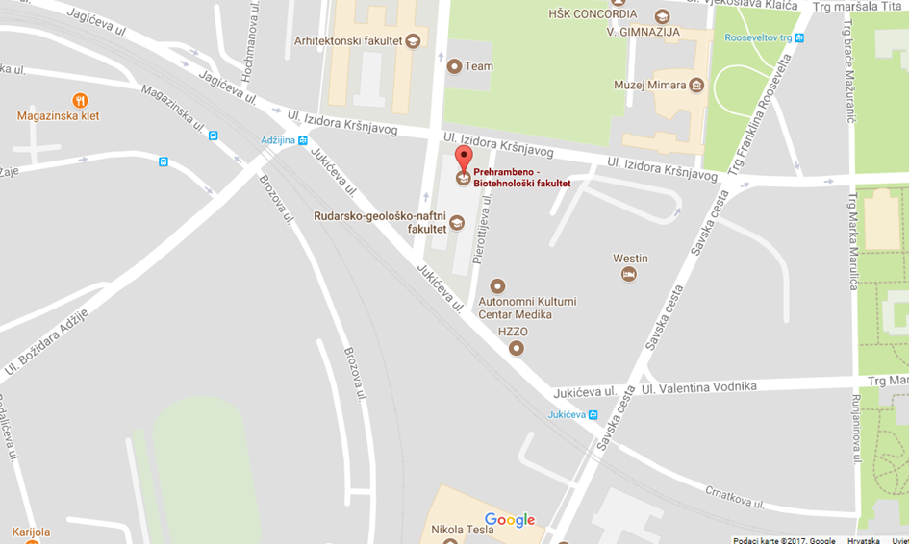

If you start from Ban Jelačić Square (main Zagreb square) you can use trams number 12,14 and 17. You should get off at Vodnikova ulica (Vodnikova Street) stop. The tram stop is right in front of Hotel Westin. It is also possible to walk from Ban Jelačić Square to Hotel Westin (approximately 15 to 17 minutes).
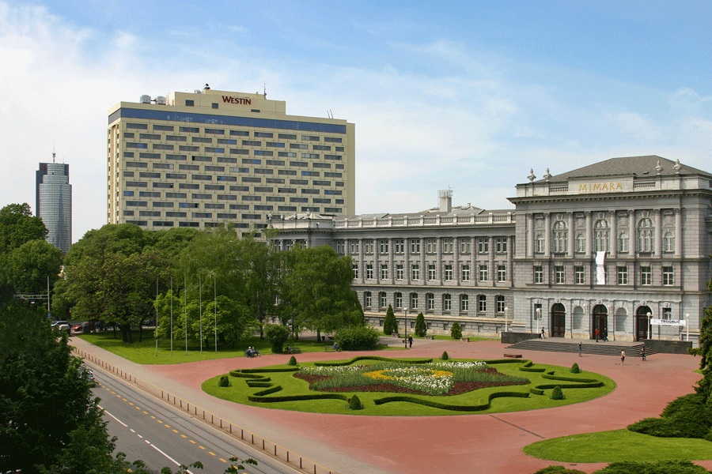Hotel Westin
The Faculty of Food Technology and Biotechnology is behind the hotel, 3 minutes walk.

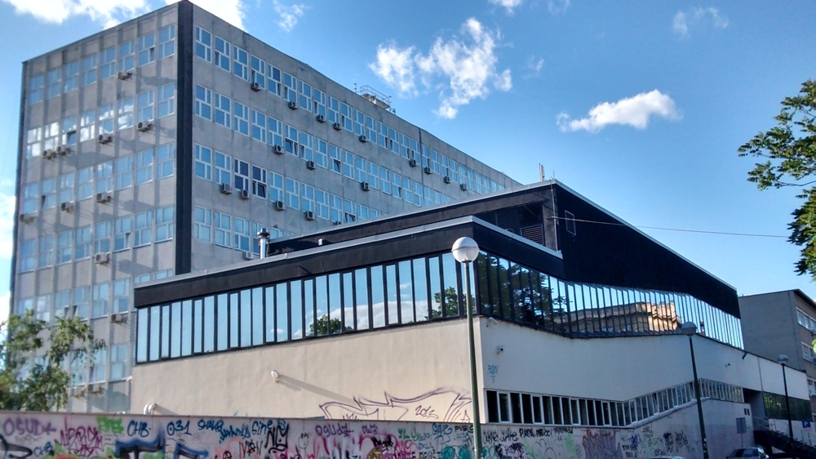
Faculty of Food Technology and Biotechnology
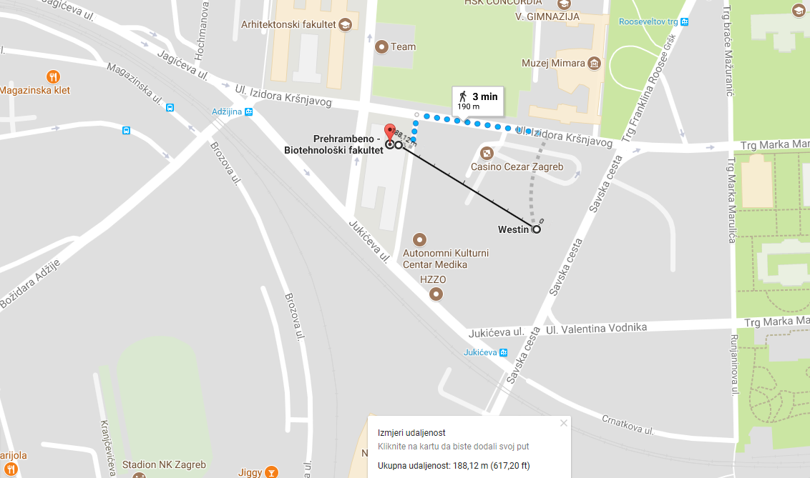

From Zagreb airport to the city centre
The Franjo Tuđman airport Zagreb is situated 12 km from the city centre of Zagreb. It takes approximately 30 minutes to reach the city centre. There are two options of how to reach citiy center from the Zagreb airport:
- By BUS – there are Croatia Airlines buses waiting just outside the airport and they take passengers from the airport to the Main Bus Station every half hour. The price of a one-way ticket is HRK 30 (4 EUR).

- By Taxi- this option is faster but much more expensive (cca. 20 EUR). Also, do not in any case take the taxi displaying a yellow plate as its price is much too expensive.

From Bus station to city centre – TAXI OR TRAM
Taking a taxi is certainly more convenient and faster and not much more expensive than the tram. In case you decide for a taxi, take Taxi Cammeo which is the cheapest taxi option (Cammeo vehicles are parked opposite the Bus Station - cross the street).

If you take the tram, the tram stop is just opposite the Bus Station and you will need to take No 6 and get off at the tram stop Ban Jelačić Square. From Ban Jelačić Square you can go in any hotel that you have chosen (look at our hotel recommendation).

Daily departures from Zagreb Airport towards the Main Bus Station in Zagreb:
7.00 – 8.00 – 8.30 – 9.00 – 9.30 – 10.30 – 11.30 –12.00 – 12.30 – 13.00 – 13.30 – 14.00 – 14.30 – 15.00 – 15.30 – 16.00 – 16.30 – 17.00 – 17.30 – 18.00 – 18.30 – 19.00 – 19.30 – 20.00

* After 20.00, the buses leave following the landing of regular Croatia Airlines planes.

Daily departures from the Main Bus Station in Zagreb towards the Zagreb Airport:
4.00 – 4.30 -5.00 – 5.30 – 6.00 – 6.30 – 7.00 – 7.30 – 8.00 – 8.30 – 9.00 – 10.00 – 10.30 – 11.00 – 11.30 – 12.00 – 12.30 – 13.00 – 13.30 – 14.00 – 14.30 – 15.00 – 15.30 – 16.00 – 16.30 – 17.00 – 17.30 – 18.00 – 18.30 – 19.00 – 19.30 – 20.00-20.30.

* On Monday, Thursday and Friday, the first bus leaves at 4.30.
* On Wednesday, Thursday, Friday and Sunday the last bus leaves at 21.30.

Some suggestions for convenient accommodation:
- Garden hotel - http://www.gardenhotel.hr/
Ulica Valentina Vodnika 13, 10 000 Zagreb
Book by phone +385-1-4843-720
e-mail: info@gardenhotel.hr

(Close to the Westin hotel, but lower prices.)

- Hotel Astoria - http://www.hotelastoria.hr/hr/
Petrinjska 71, 10 000 Zagreb
Hrvatska /Croatia
tel. +385 1 4808 900
e-mail: sales@hotelastoria.hr
recepcija@hotelastoria.hr
marketing@hotelastoria.hr

- Hotel Dubrovnik - https://hotel-dubrovnik.hr/hr/
Hotel Dubrovnik d.d.
Ljudevita Gaja 1, PP 246, 10000 Zagreb
Phone: +385 1 4863-555
e-mail: info@hotel-dubrovnik.hr

- Hotel Arcotel Allegra - http://www.arcotelhotels.com/hr/allegra_hotel_zagreb/?r=3772303&gclid=EAIaIQobChMI8f_c-cWD1gIV1RXTCh3y1w9VEAAYASAAEgJsu_D_BwE
Branimirova 29 | 10000 Zagreb
T +385 1 4696-000
e-mail: reservation.allegra@arcotelhotels.com

- Hotel Palace - http://palace.hr/
Trg Josipa Jurja Strossmayera 10, 10000 Zagreb
 +385 1 4899 600
 +385 1 4811 357
→ palace@palace.hr

